**ACMV (air conditioning and mechanical ventilation)**

Effective cooling system for hospital

Hospital deploys ULPA filters to ensure quality of air is controlled. However ULPA filter restricts airflow by up to 50%. Hence there is a need to properly regulate the cool air produced by the central system.

HVAC systems in hospitals are typically installed with a damper system that are able to restricts and control the air flow to different regions individually.

<insert picture here>

Current HVAC:

Automated damper systems are rarer

Our proposed HVAC:

Monitors temperature distribution and air pressure of a hospital room to automatically control pressure and air flow dampers

Monitors air flow and pressure at the exit of the damper to ensure damper is working properly. HVAC systems breaks down often and if there is any leakage, cost incurred is large if it goes unnoticed. In the case of hospital, air pressure is also critical as air cannot be recirculated to prevent the spread of infections.

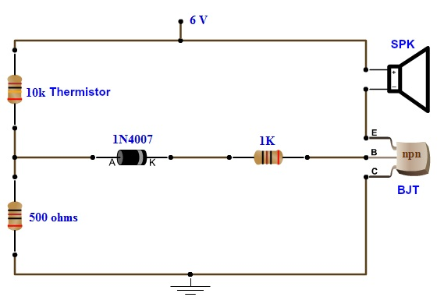<https://www.electronicshub.org/simple-fire-alarm-circuit/>

<https://www.youtube.com/watch?v=E9PSSxRO6Ik> (how to make co2 detector)

1. temp sensor

[Make Your Own Thermometer! - The Learning Circuit](https://youtu.be/Ri5ZQrSeSYk)

Things we need:

Arduino uno

OP amps

Thermistor (NPT)

MQ-135

Resistor

Jumper wires

Breadboard

Power supply

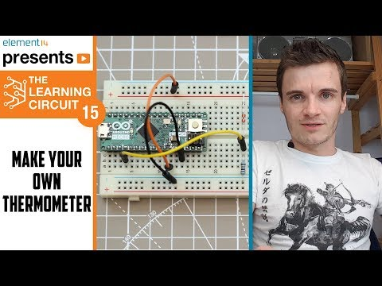

2. co2 sensor

3. damping system how

4. Dehumidifier system/leakage system

NATIONAL UNIVERSITY OF SINGAPORE

Faculty of Engineering

Engineering Science Programme

**ESP3903 Interim Report**

Major Design Project 2 – Sensors

**Group 7**

Goh Kheng Xi, Jevan A0199806L

Lock Mei Lin A020475M

Toh Wei Wen A0204844H

**19 February 2022**

**Acknowledgement**

We would like to express our deep appreciation to Professor Ernest, for his enthusiasm and guidance that have helped the whole team tremendously in our project. We would also like to express our heartfelt appreciation to Professor Nelliyan Karuppiah for his unwavering support during each laboratory session. Lastly, special thanks to Mr. Chew Yew Lin for his exemplary guidance in fabrication and the design laboratory.

Contents

**1. Executive Summary** 7

**2. Introduction** 7

**3. Ideation** 8

**5. Calibration of Thermal Sensors** 10

**6. Performance Analysis** 10

**7. Conclusion** 10

**8. Annex** 10

**8.1** **References** 10

**8.2** **Arduino Code** 10

1. INTRODUCTION 11

1. IDEATION 11

2. MECHANICAL DESIGN 11

3.1 Indoor damping system 11

3.2 Outdoor variable fan speed system 11

3. THERMAL SENSOR DESIGN 11

4.1 Design consideration 11

4.2 Electronic components 11

4.3 Electronic circuit design 11

4. CURRENT RESULTS 11

5.1 Thermal sensor 11

5.2 Thermistor 11

5. CALIBRATION OF SENSOR 11

6. AREAS FOR IMPROVEMENT 11

7. CONCLUSION 11

8. ANNEX 11

9.1 References 11

9.2 Arduino code 11

# **1. Executive Summary**

This paper presents the design and performance analysis of an Indirect Evaporative Cooling (IEC) system, paired with a dehumidification system, that is ideally powered by photovoltaic (PV) panels. The design of the IEC system was first modelled using MATLAB, where it was discovered that a reverse flow design had a better cooling effect compared to a forward flow design for channel heights below 8 mm. Further simulations using a normalized score was done to determine various parameters such as channel heights and air velocity to maximise our score.

Experiments were done using solar simulators and three different PV panels to determine each of their I-V characteristics and efficiency. Consequently, it was concluded that the monocrystalline silicon PV panel has the highest fill factor of 0.781 despite being the smallest in size, – with dimensions of 165 $×$ 135 mm – implying that it is the most space efficient.

After conducting numerous tests on the IEC and dehumidification systems post-fabrication, a maximum temperature difference ΔTmax of 0.9℃, a relative humidity difference of 23%, a cooling capacity of 174W and a Coefficient of Performance (COP) of 3.314 was obtained.

Finally, with the results obtained, it was calculated that the IEC system’s fans required a total of 52.5 W power to supply wind to the system. This means that 12 Remax Proda Notebooks will be needed to store the solar energy generated from 45 monocrystalline silicon PV panels, used to supply 52.5 W to the fans of the IEC system for 24 hours.

# **2. Introduction**

Being in the hot tropical region, Singapore experiences a maximum of about 30 to 32 degrees Celsius daily on average. Hence, buildings often deploy ACMV systems to combat the tremendous tropical heat. On average, an ACMV system accounts for more than 40% of a building’s energy consumption on average. Therefore, this project proposed the installation of sensors to control and optimise the energy consumption of ACMV systems to better match the consumption needs.

For this project, thermal sensors were designed and constructed to detect the temperature at different parts of an environment – indoor or outdoor – such that the damper system would adjust for optimal air-conditioning flow rate indoors, and to vary the fan speed for optimal cooling effect outdoors.

The project was broken down into several stages: ideating, sensor fabrication, calibration of the sensors, as well as the performance analysis of the systems. The ideating stage of the project is discussed in Section X, while the sensor fabrication is examined in Section X. Meanwhile, the sensor calibration and performance analysis of the systems are reviewed in Sections X and X respectively.

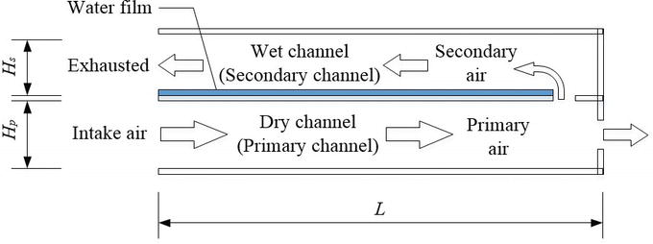  
Figure 1: Illustration of an Indirect Evaporative Cooling (IEC) System.

IEC is a method that utilizes external air to cool an internal environment. Referring to Figure 1, this method requires an air-to-air heat exchanger that consists of alternating wet and dry channels. In the process, it is important that the internal and external airstreams do not mix [1].

To start the process, hot external air is first driven into the dry channels of the cooler by a fan. As air passes through the dry channel, it is cooled by the adjacent wet channels’ surface.

When the air exits the dry channel, a portion of air is driven into the wet channel, while the remaining air escapes to form the cool product air. A study suggested that the proportion of air that is directed into the wet channel be 45%, and the remaining 55% forms the cool product air. This cooled product air is then transported into the external environment for cooling applications.

When air passes through the wet channel, water in the wet channels evaporate and produce a cooling effect on the wet channel’s surface, absorbing heat from the air in the dry channels. The air in the wet channel is then expelled as warm, moist air [2].

# **3. Ideation**

Hmm “ideation” sounds abit weird, maybe if someone got a better phrase can suggest. But basically for this part, I was thinking of stating our problem statement & why we chose to do on this alfresco dining idea. Basically expand more on intro abit. And also talk abt how our sensors will try to solve this problem. Then the benefits of this. Maybe we can talk about how thr is no such device out there now too?

‘’’

The term ‘Al Fresco’ comes from Italian and translates roughly to ‘in the cool air.’ While Al Fresco dining in Singapore is common, cool air is not as common. Therefore, a system that automates fan speed for outdoor dining and damps the aircon for indoor dining for a more efficient cooling effect would be useful for restaurants with Al Fresco dining. The system will be able to create a more comfortable eating environment for patrons of the AL Fresco restaurant, as well as energy-saving by using the outdoor fan and air-con to effectively reduce temperature where the temperature is higher within the restaurant.

Temperature sensors will be placed around the restaurant to detect the temperature at each location. When the outdoor temperature increases, the fan will increase its speed to reduce the temperature. Similarly, when the indoor temperature increases, the air-con will be undamped...? The reasons for the temperature increase could be but not limited to: an increased number of patrons and weather conditions.

Currently, there are commercial fans that change fan speed when the surrounding temperature changes. **AirEffect is one of the available control system for the MacroAir Controller 30(a fan) that senses and automatically maintains a desired room temperature. AirEffect gauges the heat index by measuring the temperature and humidity at the ceiling and floor. To achieve the desired temperature, AirEffect takes the heat index and calculates each fan’s ideal operating speed and direction and runs the fans accordingly. Simply setup AirEffect with the desired temperature range and enjoy a consistently comfortable environment.**

However, there are only 2 sensors, one on the ceiling, one on the floor for the MacroAir Controller 30. The temperature measured by the sensors can only be considered as the average temperature inside the location. The proposed system has sensors throughout the location instead, which will represent the temperature distribution of the location. Hence the proposed system improves upon the existing automatic temperature maintaining fan.

Ffff I continue tmr

**4. Design of Thermal Sensors**

Each thermal sensor is a thermistor connected in series with a 100k ohms resistor. They are then placed in parallel with one another and are distributed around the room. A change in the temperature around a thermistor will induce a change in the thermistor’s resistance and thus, causing a change in the voltage across it. This change in voltage can be recorded by the Arduino’s analog input to trigger a signal to the damper’s or fan’s motors.

# **5. Calibration of Thermal Sensors**

Calibration of the thermal sensors was performed by varying a heat source and measuring the temperature around the thermistors. Then the voltage values across each thermistor was obtained and recorded every 10ms and averaged over a period of 5 seconds.

However, there is a huge disparity between the actual voltage-temperature graph and the expected graph. Since NTC thermistors is used, the voltage is expected to drop due to the increased resistance of the thermistors as the temperature increases, but instead, an upward sloping graph was obtained.

A key contributing factor to this error is the reading from 4 analog pins without any delay between each analog pin reading, which might cause some signal interference and hence, the thermal sensors must be recalibrated.

# **6. Performance Analysis**

For this part ummm idk if we should include? Bc idk if we have any performance to analyse yet. Probably not bah. Probably until calibration only.

# **7. Conclusion**

# **8. Annex**

## **8.1** **References**

[3] https://www.pelonistechnologies.com/blog/fan-temperature-control

## **8.2 Arduino Code**

Optimising Air Flow for Indoor and Alfresco Dining

Goh Kheng Xi Jevan, *Undergraduate, ESP*, Lock Mei Lin, *Undergraduate, ESP*, Toh Wei Wen, *Undergraduate, ESP*.

***Abstract –* This project aims to optimise the airflow for indoor and outdoor dining. Using thermal and carbon dioxide sensors,**

# INTRODUCTION

Discuss the problem about alfresco and indoor dining. Talk abt the potential for energy savings + more efficient cooling effect – and citations.

We then also talk abt how we aim to solve this problem with our sensors.

‘’’

# IDEATION

We can add flow chart to show more clearly for both indoors and outdoors designs.

# MECHANICAL DESIGN

## 3.1 Indoor damping system

We talk about the panes and motors here.

## 3.2 Outdoor variable fan speed system

We talk about how we plan to vary the fan speeds here. We need to discuss more on this…

# THERMAL SENSOR DESIGN

## 4.1 Design consideration

## 4.2 Electronic components

## 4.3 Electronic circuit design

# CURRENT RESULTS

## 5.1 Thermal sensor

## 5.2 Thermistor

# CALIBRATION OF SENSOR

# Other considerations

# CONCLUSION

Here we talk about our end goal for the project and I guess how we will work towards it. Then reiterate our points.

# ANNEX

## 9.1 References

## 9.2 Arduino code